Gabon

## Freedom House political status

The data set shows the Freedom House political scores and status of the country each year.

## # A tibble: 19 x 5  
## country iso3c date mean status   
## <chr> <chr> <dbl> <dbl> <chr>   
## 1 Gabon GAB 1996 4.5 Partly Free  
## 2 Gabon GAB 1998 4.5 Partly Free  
## 3 Gabon GAB 2000 4.5 Partly Free  
## 4 Gabon GAB 2002 4.5 Partly Free  
## 5 Gabon GAB 2003 4.5 Partly Free  
## 6 Gabon GAB 2004 4.5 Partly Free  
## 7 Gabon GAB 2005 5 Partly Free  
## 8 Gabon GAB 2006 5 Partly Free  
## 9 Gabon GAB 2007 5 Partly Free  
## 10 Gabon GAB 2008 5 Partly Free  
## 11 Gabon GAB 2009 5.5 Not Free   
## 12 Gabon GAB 2010 5.5 Not Free   
## 13 Gabon GAB 2011 5.5 Not Free   
## 14 Gabon GAB 2012 5.5 Not Free   
## 15 Gabon GAB 2013 5.5 Not Free   
## 16 Gabon GAB 2014 5.5 Not Free   
## 17 Gabon GAB 2015 5.5 Not Free   
## 18 Gabon GAB 2016 5.5 Not Free   
## 19 Gabon GAB 2017 6 Not Free

## Freedom House classification of political change

The data set shows the GDP growth and the ecomic growth classification of the country each year.

## # A tibble: 19 x 4  
## country iso3c date politicalChangeFH  
## <chr> <chr> <dbl> <chr>   
## 1 Gabon GAB 1996 no change   
## 2 Gabon GAB 1998 no change   
## 3 Gabon GAB 2000 no change   
## 4 Gabon GAB 2002 no change   
## 5 Gabon GAB 2003 no change   
## 6 Gabon GAB 2004 no change   
## 7 Gabon GAB 2005 autocratization   
## 8 Gabon GAB 2006 no change   
## 9 Gabon GAB 2007 no change   
## 10 Gabon GAB 2008 no change   
## 11 Gabon GAB 2009 autocratization   
## 12 Gabon GAB 2010 no change   
## 13 Gabon GAB 2011 no change   
## 14 Gabon GAB 2012 no change   
## 15 Gabon GAB 2013 no change   
## 16 Gabon GAB 2014 no change   
## 17 Gabon GAB 2015 no change   
## 18 Gabon GAB 2016 no change   
## 19 Gabon GAB 2017 autocratization

## Freedom House score trend

The plot shows the Freedom House scores trend of the country.

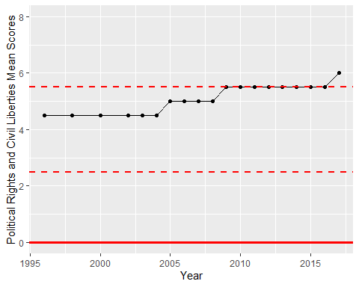

Freedom House Score Trend